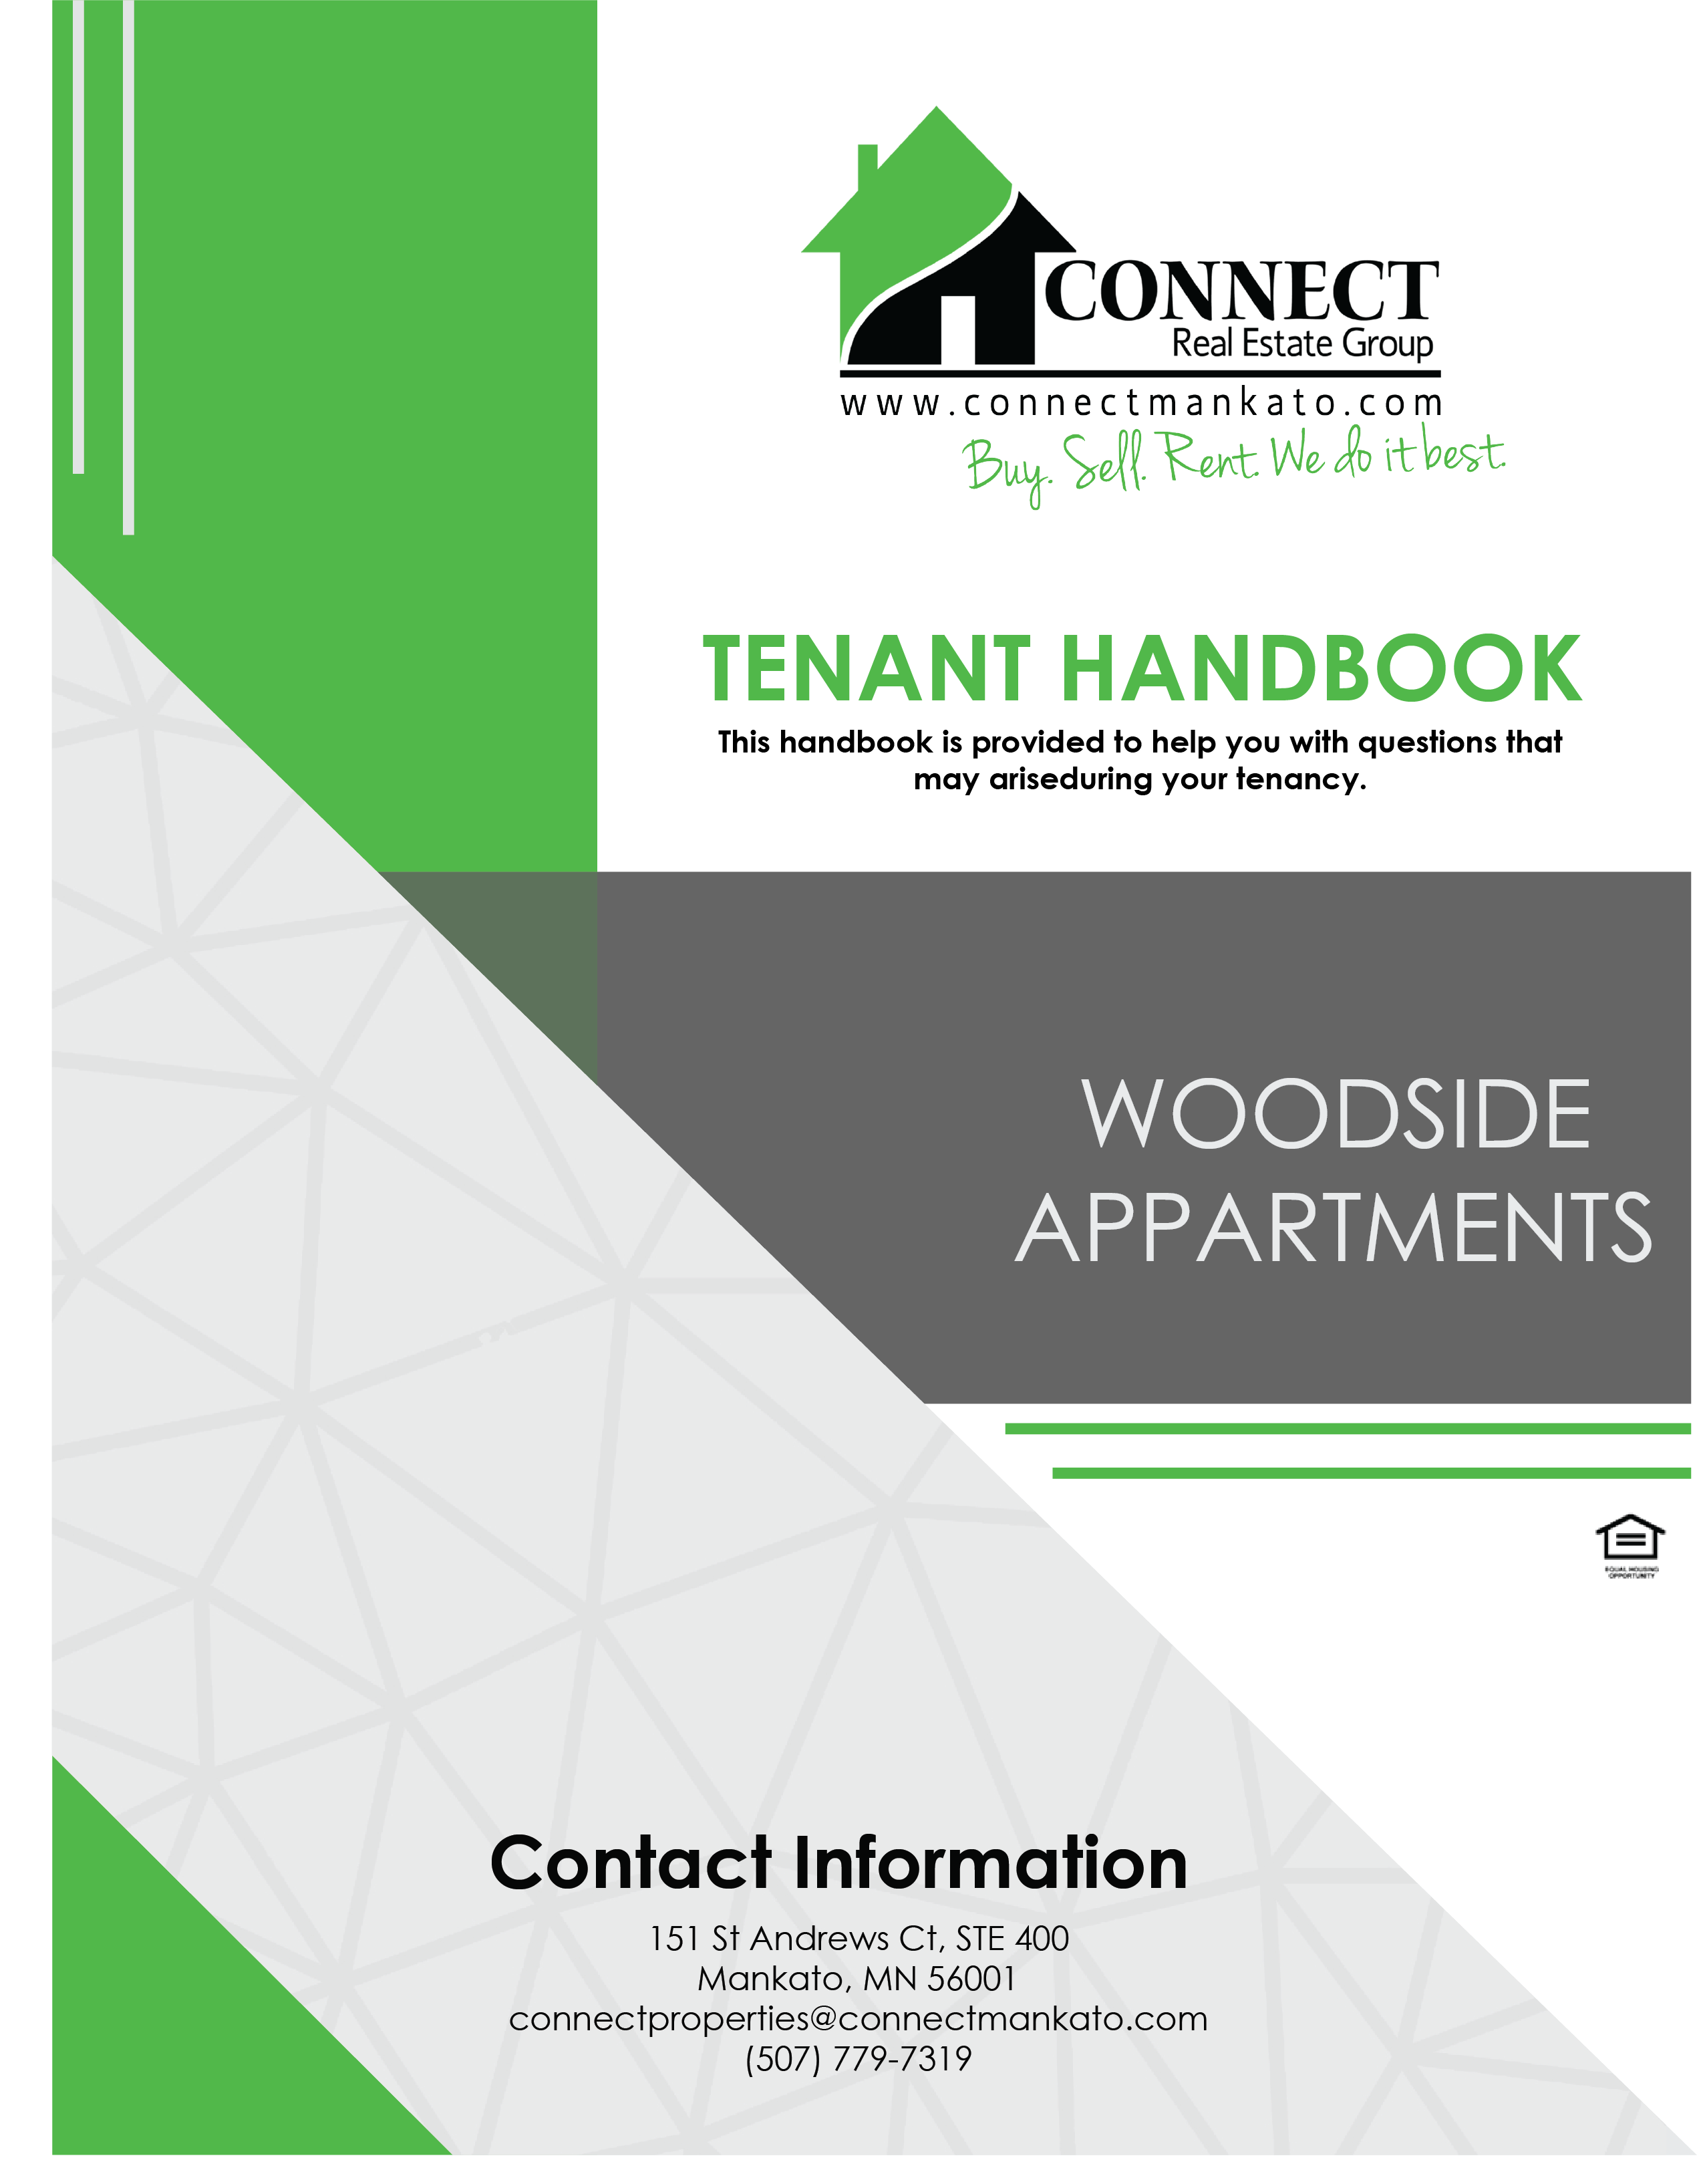

Table of Contents
This handbook is provided to help you with questions that may arise during your tenancy.

Table of Contents…………………………………………………………………………………………. Page i
Contact Page………………………………………………………………………………………………… Page ii
Section One: MOVE IN
Address................................................................................................. Page 1
Utilities.................................................................................................. Page 1
Payment of Rent.................................................................................... Page 2
Move In Inspection................................................................................ Page 2
Fees...................................................................................................... Page 2
Section Two: THE TENACY
Maintenance/Repairs............................................................................ Page 3
Lawn Care/Snow Removal...................................................................... Page 3
Smoke Detectors ETC............................................................................. Page 3-4
Disorderly Apartment............................................................................ Page 4
Vehicle Parking...................................................................................... Page 4
Smoking................................................................................................ Page 4
Windows & Screens............................................................................... Page 4
Vacuuming............................................................................................ Page 4-5
Guests................................................................................................... Page 5
Alterations to Unit................................................................................. Page 5
Apartment Wall Policy.................................................................. Page 5
Heat...................................................................................................... Page 5
Lockouts……………………………………………………………………………………………… Page 5
Policy on Disturbances/Security............................................................. Page 6
Section Three: MOVE OUT
Move Out.............................................................................................. Page 7
Move Out Condition…………………………………………………………………………….. Page 7-8
Return of Deposit.................................................................................. Page 8
Repairs.................................................................................................. Page 8

Contact Information

Woodside Apartments  311 E. Roosevelt Circle  Mankato MN, 56001  Office Hours  Monday: 9-5pm  Tuesday: 9-5pm  Wednesday: 9-5pm  Thursday: 9-5pm  Friday: 9-5pm  Saturday: Closed  Sunday: Closed | Connect Office  151 St. Andrews Ct. Ste 400  Mankato MN, 56001  Office Hours  Monday: 9-5pm  Tuesday: 9-5pm  Wednesday: 9-5pm  Thursday: 9-5pm  Friday: 9-5pm  Saturday: Closed  Sunday: Closed

Woodside Office: (507) 625-8612
Connect Property Management: (507) 345 6518
Connect Real Estate Group: (507) 779 7319
Property Manager (Kellie): (507) 399-9889
Property Manager (Christa): (507) 327-6300

After Hours Emergency: (507) 399-9889
Emergency: 911

www.rentwithconnect.com
connectproperties@connectmankato.com
Section One
MOVING IN

ADDRESS
(Your Building Number) E Roosevelt Circle Apt. (Your Apt. Number) Mankato, MN 56001

Change your address at the Post Office: 1400 Madison Ave #328, Mankato (In the Madison East Mall)
Or at usps.com (Select “change your address” under “manage your mail”).

UTILITIES
Please call the utility companies and put in your name AT THE TIME of move in.
IF YOU FAIL TO CHANGE THE UTILITIES INTO YOUR NAME, YOU WILL BE CHARGED A $25 FOR EACH OCCURANCE THE OFFICE RECIEVES YOUR BILL.

Tenants are responsible to pay electric, water/sewer, cable, internet, telephone, and gas.
All questions concerning billing and usage after move in should be directed to service provider.

Electric: Xcel Energy……………………………................................... +1 (800) 895-4999
Gas: Greater Minnesota Gas………………………………………………… +1 (888) 931-3411
Internet and Cable: Consolidated Communications…………….. +1 (844) 423-8822
Water: Billing is done by Woodside. You will receive your bill on your door monthly. Please remit
payment to Woodside Apartments.

- You will be asked to fill out a new move in form that will be faxed to service provider for initial set up your account. YOU will still need to contact provider to assure service has been transferred to your name.
- Management recommends all tenants set their account on the Budget plan. These plans allow tenants to spread out payments for high usage periods over the course of a year rather than receiving large, unexpected bills within a usage period. You will need to notify service provider of your wish to participate in these programs.
- Invoices for water/sewer unit consumption will be distributed by Connect Property management to your apartment door. Water meters are read monthly by staff. Each unit is responsible for full payment.
- TRASH: It is YOUR RESPONSBILITY to dispose of any car parts, TVs, tires, electronics, or anything else that cannot be accepted by the refuse hauler. ALL TRASH MUST BE PLACED & FIT into the dumpsters/containers provided. The cost of removing any unclaimed garbage that hauler will not take will be billed to the rental unit or the whole complex. Please report to US if someone is inappropriately disposing of non-accepted items.

PAYMENT OF RENT
EACH TENANT SIGNED ON THE LEASE IS INDIVIDUALLY AND JOINTLY RESPONSIBLE FOR PAYING THE FULL AMOUNT OF RENT AND ANY OTHER MONEY OWED TO MANAGEMENT.

ALL RENT IS DUE FIRST DAY OF EACH MONTH!

- Payments NOT RECEIVED by 5pm on the 5TH of EACH MONTH will 8% SERVICE CHARGE added to their account.
- If all rent is NOT received by the 10th of the month, Management may begin the eviction process for ALL tenants, and ALL tenants will be responsible for ALL past due rent, late fees, court costs and reasonable attorney’s fees.
- There is a $30 charge for all RETURNED/NSF checks. ALL future payments must be in CASH or CERTIFIED Funds only.
- CASH, CHECK, MONEY ORDER, CASHIER’S CHECK, or BILL PAY CHECKS
  - To ensure checks are processed, please make checks payable to: WOODSIDE APARTMENTS
- CASH payments must be for exact amount; change will not be issued. Credit will be issued for overpayment of amount on the account.
- WATER BILL PAYMENTS ARE DUE 2 WEEKS AFTER RECEIPT OF BILL ON YOUR APARTMENT DOOR.
  - IF NOT RECEIVED BY THE 5TH OF THE MONTH A $50 LATE FEE CAN BE ASSESSED
  - AFTER 2 MONTHS OF NON-PAYMENT WATER SERVICE WILL BE SHUT OFF TO UNIT UNTIL PAID
- Payments may be dropped at the designated 24 hour drop box LOCATED IN THE #311 BUIDING, given to office staff during office hours, or dropped at Connect Real Estate Group’s Office location.
- PLEASE INCLUDE YOUR UNIT # as well as BUILDING # (ex. 211-2) on the check to ensure we apply your payment to the correct account.

MOVE IN INSPECTION
- Please inspect your unit thoroughly at move in. Tenant is responsible for filling out move in walk through documentation. Please note items that are damaged, need repair, etc. RETURN this to the office within 3 days of your move in date for it to be valid. You will be charged for undocumented damages beyond normal wear & tear to your unit at the end of your lease.

FEES
- Apartment/Mail Key – $40, plus the cost of re-key.
- FOB Key – $25
- Failure to clean up dog waste – $50 for 1st, $100 for 2nd
- Garbage – Cost of removal or minimum of $10 per bag
- Late Rent – 8% of rent amount not paid
- Lockout – $50
- Non-Sufficient Funds Check – $30
- Unauthorized Pet – $800 per pet
- Authorized Pet – $400 for 1 pet
- Unauthorized Resident – $250 per week, per occupant

Section Two
THE TENACY

MAINTENANCE/REPAIRS:
Non-emergency requests (those not posing immediate damage to property or tenants) must be submitted ONLINE or VIA form OUTSIDE OFFICE.

- Online: www.rentwithconnect.com Click on “Maintenance” tab
- Form: Located outside the office in 311 Building (Building #1). Fill out FULLY and drop in the drop-box or submit to office staff.

**EMERGENCY REQUESTS (toilet overflowing, water leaking, other items causing immediate damage) should be reported to management IMMEDIATELY at (507) 399-9889.

**GAS LEAKS should be reported to Service Provider Greater Minnesota Gas (888) 931-3411 FIRST, Management SECOND

- BURNT OUT LIGHTBULBS (except prong light bulbs & stove bulbs) ARE TENANT RESPONSBILITY. If replaced by staff, there will be a charge added to your account of $50.
- Keep at least ONE plunger in your unit at all times. If maintenance staff must remove a foreign object from your toilet, sink, tub or PLUNGE your toilet (1 initial time is allowed) you will be CHARGED accordingly.
- In an emergency you may need to shut off your electrical power. Learn the location of your breakers.

LAWN CARE/SNOW REMOVAL
Management will provide lawn care and snow removal for all units. Tenants are responsible for maintaining the yard free of garbage, debris and waste. Tenants must cooperate with snow removal procedures, which may mean moving cars to another parking lot/area.

SMOKE DETECTORS/CARBON MONOXIDE DETECTORS/FIRE EXTINGUISHERS
Each rental unit is equipped with smoke detectors, fire extinguishers, and carbon monoxide detectors. It is your responsibility to make sure they are hooked up and functioning. If a detector is determined inoperative, you must contact management immediately. We will confirm units are working at move in/move out and if they are missing or damaged you will be charged for replacements.

- Smoke detector batteries will be changed by management for no charge, or if you wish to change the battery because of beeping you may do so with a standard 9 Volt Battery.
- City inspections will occur in random units on occasion and if they note/fine the building for removal or damage of the detectors, the fine will be added to your account.
- IT IS ILLEGAL TO DISCONNECT SMOKE DETECTORS/CARBON MONOXIDE DETECTORS. YOU AND YOUR ROOMATES MAY BE CHARGED WITH A MISDEMEANOR FOR DISCONNECTING OR DISABLING THEM, AS WELL AS A $250 FINE ISSUED TO YOUR UNIT.
- Do not tamper with or remove the fire extinguisher. In the event it is used in an emergency, please contact management to receive a new one.

DISORDERLY APARTMENT
At certain times management may choose to inspect your rental unit for upkeep and condition. If it is determined that your unit is being abused beyond normal wear and tear you will receive a notice for a disorderly unit. It will be your responsibility to clean, repair, replace items as outlined in this notice. This included pest removal costs. Failure to do so will result in violation of the lease and tenant will incur a fine/eviction.

VEHICLE PARKING
Tenants should use the off street parking at all times. Management reserves the right to implement parking passes if parking becomes an issue.
- All motorcycles must have a kickstand pad and will be assessed a $150 fee per incident.
- If parking a trailer, boat, or other large oversized vehicle. Please be courteous and try to minimize the number of spots used up. DO NOT block the sidewalk, aisles or garages. This may result in having to move your vehicle/trailer or towing.

SMOKING
All buildings and attachments are smoke free. Smoking indoors is prohibited. It is illegal per MN State law, and will result in a violation of your lease. Any violations will result in $200 FINE and a LEASE VIOLATION! ALL tenants must smoke outside and dispose of cigarette butts properly.

FIREARMS
Connect Property Management does allow the storage of firearms in resident’s apartments. Residents must have appropriate permit & licenses. Firearms MUST be LOCKED or SECURE when stored in rental units or garages.

WINDOWS & SCREENS
Screens are difficult to remove correctly and can be easily damaged. If you damage the screens and they need to be replaced, it will be billed to your unit. Please avoid hitting them with objects, furniture, etc. Tenants are prohibited from removing the screens except for in case of emergency evacuation.

VACCUMING
If you do not own a vacuum cleaner, please procure one. Regular vacuuming and cleaning of your flooring will greatly deter excessive wear and tear. If you stain your carpet, please let management know, and try to clean. It may be best to shampoo the carpets as well.
- CARPETS MUST BE PROFESSIONALLY CLEANED prior to move out – as stated in security deposit notice & lease. This is either done are your expense and receipt provided to management as proof, or management will arrange and the cost will be deducted from your deposit.
GUESTS
Please limit the number of guest to your home, and immediately ask guests to leave if they become unruly. You are responsible for your guest’s actions and if complaints or damaged is received as a result of your guests, you will be held responsible.
- After 2 weeks (14 consecutive days) guests are considered to be residents and MUST be added to the lease. Units with unauthorized occupants will be charged $250 per person PER week. You will be in violation of your lease, and receive a notice to remedy situation, or an eviction will be started.

ALTERATIONS TO UNIT
- DO NOT PAINT OR WALLPAPER, MAKE ANY STRUCTRUAL OR FLOORING ALTERATIONS.
- DO NOT REMOVE ANY FIXTURES supplied by management.

APARTMENT WALL POLICY
- Resident is allowed to hang items with nails only. Resident must not patch their own nail holes prior to move out.
- Sheetrock Anchors are NOT allowed on any walls. If RESIDENT VIOLATES THIS POLICY, there is a $25 charge PER hole will be assessed at move out.
- TV Mounts- Resident will be charged $100 PER MOUNT at move out for wall damage.
- Any Additional wire shelving or other shelves mounted by resident MUST BE LEFT ON WALLS AT MOVE OUT, or there will be a charge of $100 PER SHELF.

HEAT
Tenants are responsible for keeping the heat on to prevent freezing of the pipes. Please keep the unit at a minimum of 65 degrees in the winter, especially when gone. Please ensure windows & patio doors are fully closed & locked to minimize heat loss.
- IF your gas service is disconnected due to NON PAYMENT, Greater MN Gas will require a gas inspection which is $75 prior to reconnection. This amount must be PAID PRIOR to GAS INSPECTION to WOODSIDE. The gas company will also charge you $75 to re-connect your gas service after inspection. This is payable to the gas company.
- Damages due to frozen pipes can amount to thousands of dollars and resident will be responsible for any costs of repairs deemed as a result of their actions.
- Please alert management IMMEDIATELY if you feel your furnace is NOT functioning properly or your Carbon Monoxide detectors goes off.

LOCKOUTS
Management will try to accommodate and assist during a lock out. Apartment doors are deadbolts, locked from outside, so it should be nearly impossible to get locked out.
- Tenant will be charged $50 for a lock out assistance. Payment is due with next month’s rent. Failure to remit payment will result in loss of lock out assistance.
- If you are unable to gain access to building through electronic doors, tenant may dial their own dial code, and buzz in, or if they do not have their cell phone, dial 9999 and explain situation and management will buzz you in.

POLICY ON DISTURBANCES/SECURITY
Please contact the office during business hours or the after hour phone line for non-life threatening concerns, such as noise disturbances.
- Contact 911 for life threatening concerns, such as an intruder, violence or medical issues.
- Connect Property Management reserves the right to enforce a fine and/or take further action against units responsible for excessive disturbance calls.
- The City of Mankato has a policy concerning disturbance complaints. Disturbances can be noise, party, animal, or exterior related. Any rental unit receiving two (2) complaints or strikes in a twelve-month period brings rental license under review for revocation or suspension. It is critical that you respect your neighbors use and enjoyment of their property. Tenants are responsible for the actions of your guests.
- The following fines will be charged for violation of your lease agreement if a strike is issued against the property:
  - 1st strike: One-half (1/2) month’s rent plus possible eviction
  - 2nd strike: One (1) month’s rent plus possible eviction
  - 3rd strike: Immediate eviction and responsible for the rent due for the remainder of the lease agreement and/or license suspension period, whichever is greater
- If a Problem Solving Conference (PSC) is required by the City of Mankato, all tenants MUST attend. A PSC is conducted between Management, tenant(s) and a Mankato Police Commander when a total of two (2) strikes have occurred within a twelve-month period. The goal of the PSC is to develop a plan of action to reasonably insure that a future incident will not occur at the premises. The unit may also be placed on the “Zero Tolerance List.” Failure to attend the PSC will result in immediate eviction.

IF THE CITY REVOKES OR SUSPENDS THE LICENSE FOR THE BUILDING AND/OR YOU ARE EVICTED; YOU WIL STILL BE RESPONSIBLE FOR THE RENT DUE FOR THE REMAINDER OF THE LEASE AGREEMENT AND THE LOSS OF INCOME RESULTING FROM REVOKED OR SUSPENDED RENTAL LICENSE.

NOTE! ANY VIOLATION OF CITY CODE WILL BE CONSIDERED A VIOLTION OF YOUR LEASE, AND YOU WILL BE SUBJECT TO TERMINATION OF YOUR LEASE AND/OR EVICTON.

Section Three
MOVING OUT

MOVE OUT
- All keys & remotes issued to you must be returned at move out. There is an automatic deduction of $150 from deposit if all keys are not returned on or before lease end date for required lock change. Any missing fobs will be $25 each, missing keys are $40 each (plus the cost of re-keying unit), and missing remotes are $80 each.
- Each tenant must provide a forwarding address and return keys.
- You must be out of your unit by NOON according to your lease end date. Items must be removed and cleaning completed by this time, and a walk through completed with staff. Anything still in the unit or not cleaned will be charged $50 an hour to remove/clean.
- Tenants must call all utility companies to stop service. Tenant is responsible for return all cable/internet equipment to service provider.
- ALL tenants must be present at final walk through, or given written notice to management that they will not be attending and are waiving this right.

MOVE OUT CONDITION
As a rule, we are looking for your unit to be left in a rentable state with NO work necessary to get it in shape for next tenant. THIS INCLUDES, but is NOT LIMITED TO THE FOLLOWING:
- Carpets Vacuumed (MANAGEMENT WILL ARRANGE PROFESSIONAL SHAMPOOING & DEDUCT FROM DEPOSIT)
- Hard floors Swept & Mopped
- Kitchen appliance cleaned inside, outside, behind and underneath:
  - Refrigerator – defrost if applicable
  - Stove – hood, exhaust fan, burners
  - Oven – racks, broiler, knobs/burner
  - Dishwasher – drain cleaned, and wiped out
- All cabinets empty and wiped inside and outside
- Windows and sills cleaned inside. DO NOT REMOVE windows for cleaning
- Walls, doors, woodwork
- Kitchen and bathroom sinks/toilets/fixtures cleaned – including drains cleaned of hair and draining freely
- Garage – emptied & swept out
- Light fixtures, including bathroom exhaust fans, cleaned with working bulbs
- Apartment Cleaning - $50 per hour, minimum 1 hour charge
- Blinds – clean and operational
- Heating/Cooling vents and registers cleaned and wiped off
- Washer and Dryer – wiped down inside and out, lint removed
- Smoke detectors – connected and operational
- All trash and debris removed from inside & outside of unit and disposed of properly
- DO NOT FILL YOUR NAIL HOLES – MGMT WILL DO – If there are large anchors, or excessive holes, management will deduct from your deposit for these repairs.

RETURN OF DEPOSIT
Deposit will be returned in for the amount paid if:
- Tenants have not violated any terms of lease
- Given written 60-day notice of intent to vacate
- No damage beyond normal wear and tear
- Entire unit is cleaned
- Tenant has paid all rent, late charge and other debt owed
- All keys, remotes, fob keys have been returned
- All debris, trash has been placed in disposal containers and personal property removed
- All tenants left forwarding address
- Tenant has paid off all other debts to service providers/utility companies

A copy of computation detailing charges, if any, along with all security deposit money due to you will be mailed within 21 days of the expiration of your lease.
- Questions regarding your computation must be submitted in writing, within 15 days of receipt. We will be happy to pull your file and re-check. If we have made an error, we will adjust. Due to time involved in getting answers we will only respond to those questions submitted in writing. We will answer all requests for file review in a timely manner. Please email questions to connectproperties@connectmankato.com

REPAIRS
- Blinds – $50 each
- Burned out/Missing Light Bulbs at Move Out – $10 each
- Excessive carpet wear – $2 per yard
- Carpet Replace – $25 per yard
- Entry Door Repaint – $75
- Entry Door Replacement – $350
- Fire Extinguisher Replacement – $75
- Interior Door Replacement – $175
- Outlet/Switch Covers – $10 each
- Repainting – $50/Hour
- Smoke/CO2 Detector Replacement – $50 each
- Toilet Plunging/Drain Cleaning Due to Tenant Neglect/Negligence – $50 per incident
- Unnecessary Service Calls – Cost of Visit, minimum of $50 each
- Window Glass Replacement – $100 each
- Screen Replacement – $55 each, Patio Door Screen $100
- Cleaning
  - General Cleaning – $50/Hour * MINIMUM OF A 1 HOUR CHARGE*
  - Sheetrock patch/repair – $50/Hour
  - Carpet Shampooing – Based on unit size
  - Landscaping/Grass Repair – $50 per hour
- Gas Inspection & Reconnection
  - Inspection: $75
  - Re-connection $75

